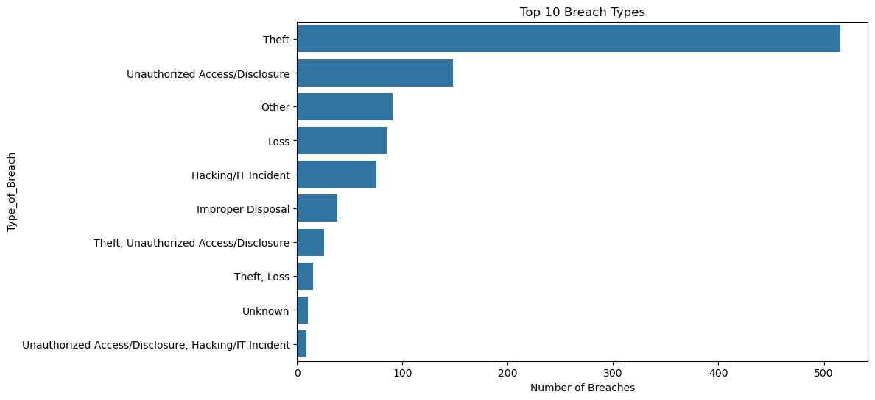

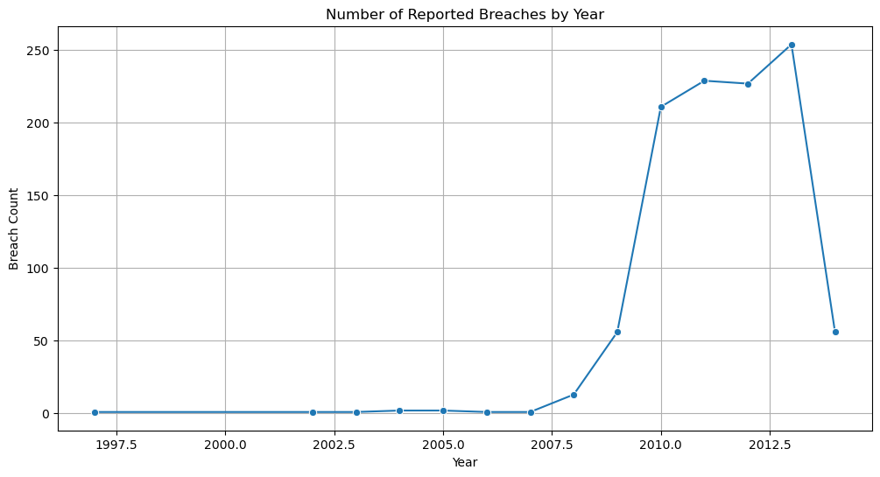
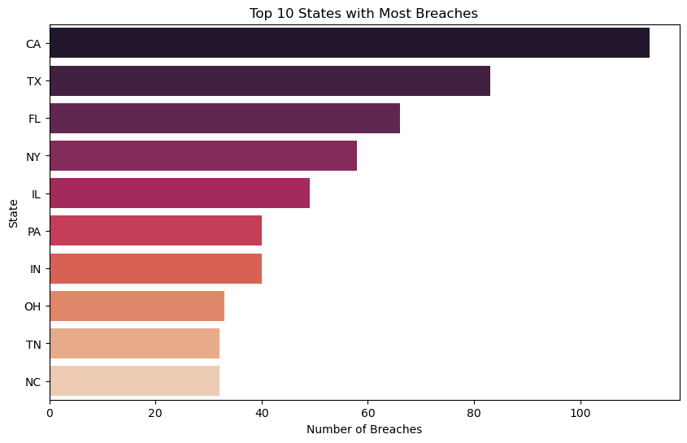
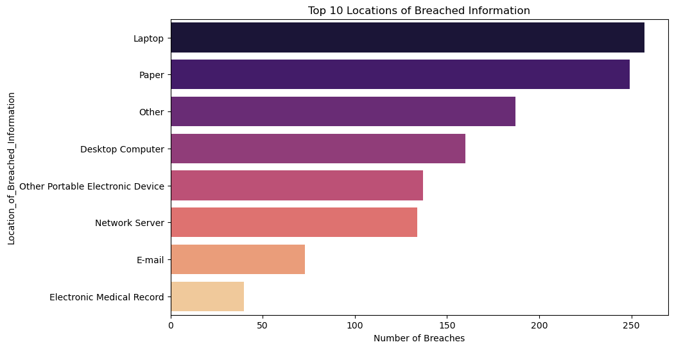
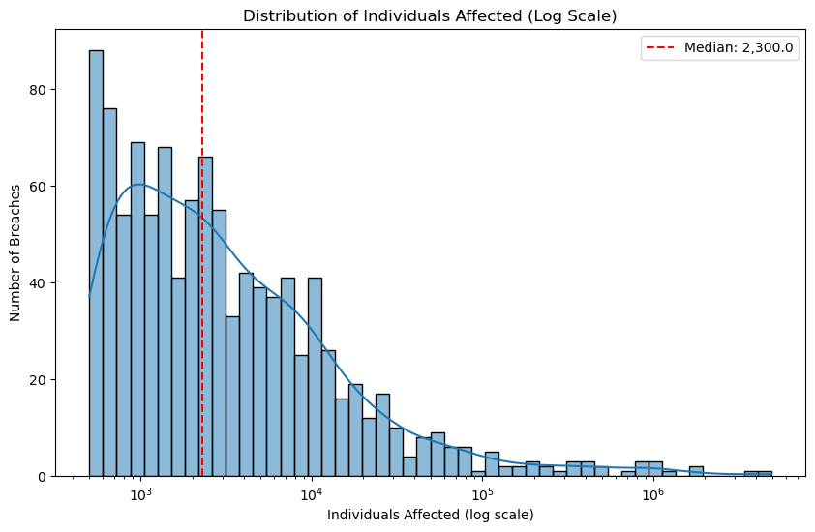
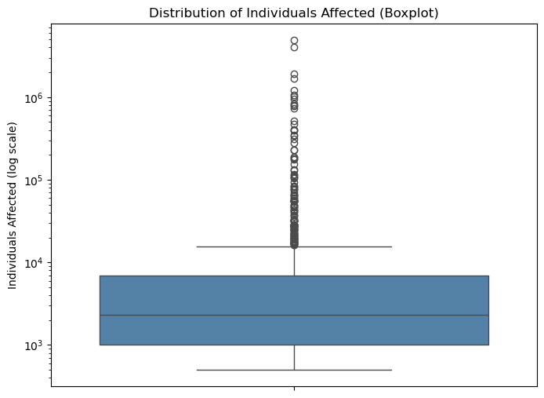
SUMMARY

Public Dataset EDA: Industry Benchmarking (Cybersecurity)

This exploratory data analysis (EDA) was performed on a public cybersecurity breach dataset to identify patterns and trends in data breach incidents. The dataset was cleaned and analyzed using Python, Pandas, Matplotlib, and Seaborn. The analysis focused on breach types, yearly trends, geographic distribution, breach storage locations, and the impact of breaches.

Key Trends

- Theft is the Leading Cause of Breaches: Theft of physical devices and records accounts for far more reported breaches than any other category, followed by unauthorized access/disclosure and hacking/IT incidents.

- Data Breaches are Increasing Over Time: The number of reported breaches has generally increased over the years, indicating a growing need for stronger cybersecurity measures.

- Certain States Report More Breaches: California and other technology-focused states experience a higher number of reported incidents, likely due to their larger digital presence.

- Laptops and Paper Records are the Most Common Breach Vectors: Physical laptops and paper documents are involved in more breaches than any digital storage medium, including desktop computers, network servers, or email.

- Breach Impact Varies Significantly: While many incidents affect relatively few individuals, some large-scale breaches impact millions, demonstrating the potential severity of cyberattacks.

Conclusion: The analysis highlights that cybersecurity threats continue to grow in both frequency and impact. Organizations should prioritize strong security controls, regular system updates, employee awareness training, and effective data protection strategies to reduce the risk of future breaches.

